Documentation

USERNAME (ADMIN) : admin@orizin.com

PASSWORD : adminorizin

USERNAME (USER) : andrew@orizin.com

PASSWORD : asdasd

* + - **Admin**
* Home
* Manage User’s Transactions
* Manage Games
* Manage Users
* Manage Game Genres
* Logout
  + - **Member**
* Home
* Store
* Profile
* Member’s Games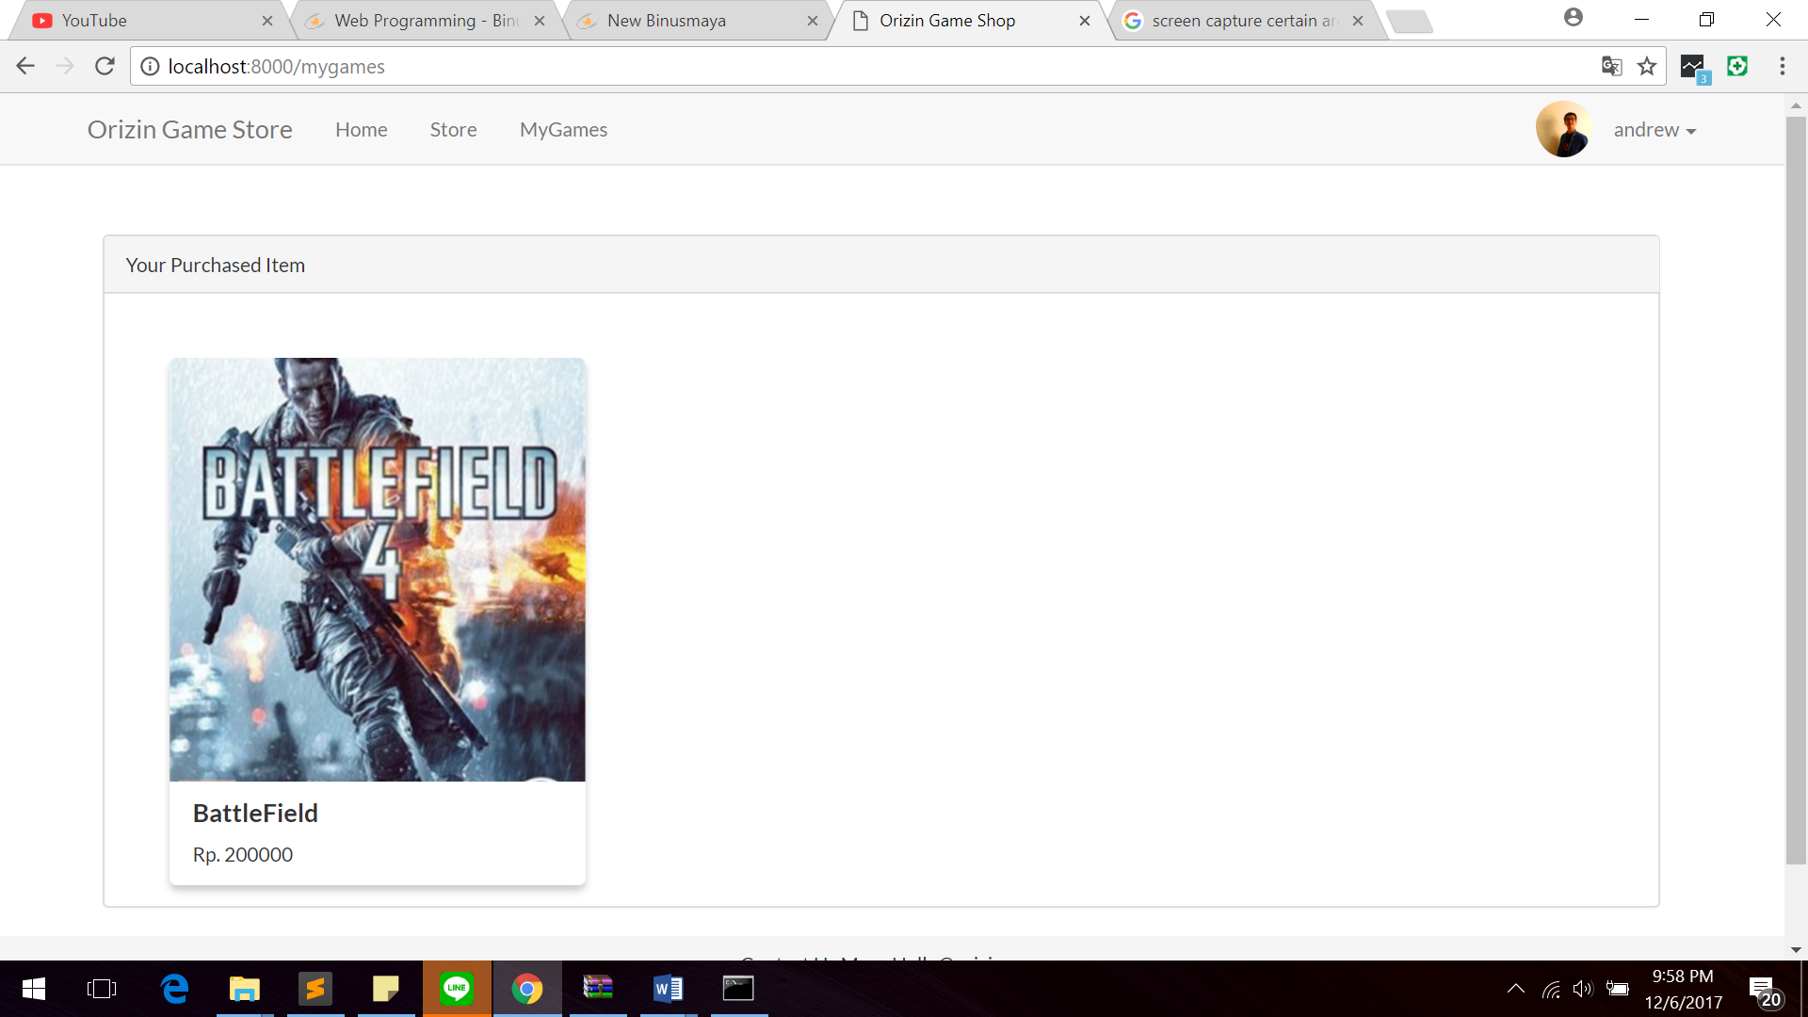
* Cart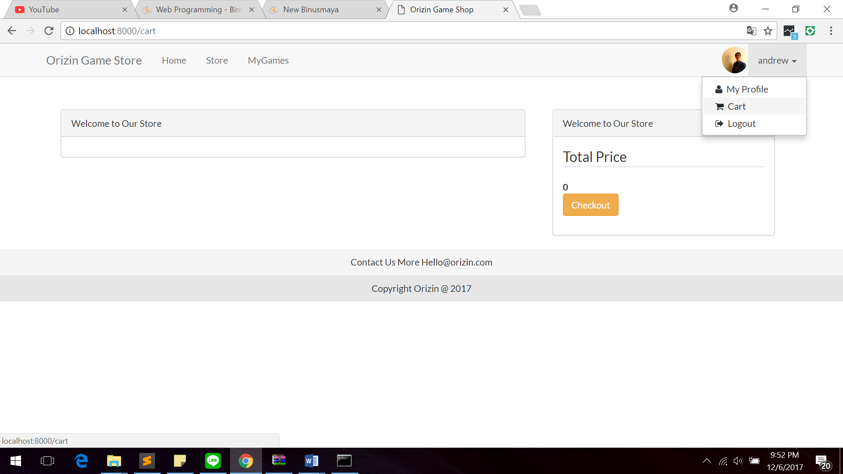
* Logout

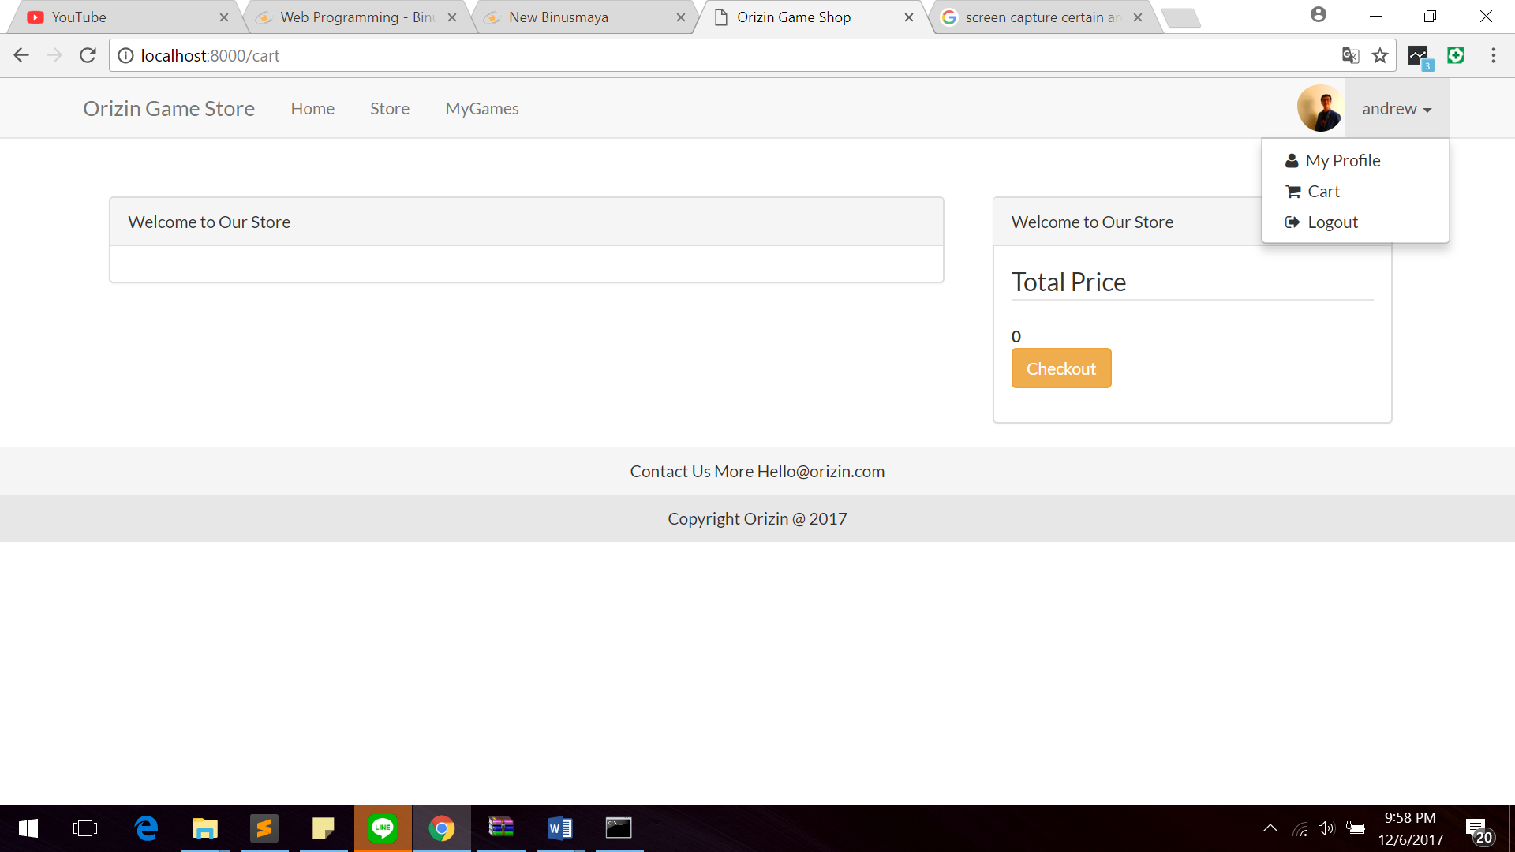

* + - **Guest**
* Home
* Store
* Login
* Register

Soure:

Bootsrap Framework for User Interface

http://getbootstrap.com/

Fontawesome

http://fontawesome.io/

font Lato

https://fonts.google.com/specimen/Lato

Img

FFXV

https://i.pinimg.com/736x/ac/9b/f3/ac9bf30c33437da86aa3dce2d63351e5--final-fantasy-xv-finals.jpg

https://i.gadgets360cdn.com/large/ffxv_cover_us_1479897071375.jpg

COD

http://i.jeuxactus.com/datas/jeux/c/a/call-of-duty/xl/call-of-duty-4e26498e6e314.jpg

Battlefield

https://www.aktifoyuncu.org/Uploads/UrunResimleri/buyuk/battlefield-4-origin-pc-cd-key-a02b.jpg

https://data3.origin.com/content/dam/originx/web/app/games/battlefield/battlefield-4/battlefield-4-standard-edition_pdp_3840x2160_en_WW.jpg

Overwatch

https://assets2.razerzone.com/images/overwatch-landing/ce1763642875fa9baf40236130a584c7-overwatch-landing-header-bg.jpg

admin

https://upload.wikimedia.org/wikipedia/commons/thumb/3/34/PICA.jpg/1024px-PICA.jpg